Batch: C3 Roll No.: 16010123217

Experiment No. 02

Grade: AA / AB / BB / BC / CC / CD /DD

Signature of the Staff In-charge with date

TITLE: Develop and demonstrate the usage of inline, internal and external style sheet using CSS

AIM: To demonstrate the CSS.
______________________________________________________________________
Expected Outcome of Experiment: Use CSS to prepare the layout of web pages.
________________________________________________________________
Books/ Journals/ Websites referred:

- https://developer.mozilla.org/en-US/docs/Web/CSS.
- https://developer.mozilla.org/en-US/
- https://developer.mozilla.org/en-US/docs/Web/HTML

_____________________________________________________________________
CSS :
External CSS in file style.css
*{
padding: 0;
margin: 0;
}

.components{
display: flex;
}
.one> a> img{
height: 90px;
width: 160px;
margin: 20px;
border-radius: 15px;
}

.container2{
height: fit-content;
width: 100%;
background-color: #6E07F3;
display: flexbox;
justify-content: center;
align-items: center;
}
h1,h2,p{
color:aliceblue;
padding-block-start: 15px;
padding-left: 15px;
padding-block-end: 15px;
}

footer{
height:fit-content;
width: 100%;
display: flex;
justify-content: center;
align-items: center;
}
footer>img{
height: 54px;
width: 96px;
}

.card>div>ul{
font-size: 1rem;
font-weight: bold;
}

body{
background: #e9fcfc;
}
Internal CSS
<style>
#picture {
display: flex;
justify-content: center;
margin-bottom: 15px;
}
</style>

Inline CSS and Html Code
(Images are stored locally so, if we run this code the images will not be displayed)

<!DOCTYPE html>
<html lang="en">
<head>
<meta charset="UTF-8">
<meta name="viewport" content="width=device-width, initial-scale=1.0">
<title>Document</title>
<link href="https://cdn.jsdelivr.net/npm/bootstrap@5.3.2/dist/css/bootstrap.min.css" rel="stylesheet" integrity="sha384-T3c6CoIi6uLrA9TneNEoa7RxnatzjcDSCmG1MXxSR1GAsXEV/Dwwykc2MPK8M2HN" crossorigin="anonymous">
<link href="https://cdn.jsdelivr.net/npm/bootstrap@5.0.0/dist/css/bootstrap.min.css" rel="stylesheet" >
<link rel="stylesheet" href="./style.css">
<style>
#picture {
display: flex;
justify-content: center;
margin-bottom: 15px;
}
</style>
</head>
<body>
<div class="container-fluid">
<div class="components">
<div class="Component one" id="logo">
<a href="https://www.linkedin.com/in/omthanage/"><img src="./logo1.PNG" alt="logo.png" />
</a>
</div>
<div class="Component two" id="contact" style="display:inline-flex;height:90px;width:160%;margin:20px;border-radius:15px;justify-content:flex-end;align-items:center;">
<a style="text-decoration: none;" href="">Say Hello!</a>
</div>
</div>
</div>
<div class="container2">
<div class="container2" id="intro">
<h1 align="center">Hi, I'm Om. Nice to meet you</h1>
<p>The advancing programmer is immersed in the word of code. I have worked with my teams at school and state-level competitions."Alone we can do so little, together we can do so much". With a knack for innovation and insightful problem-solving, I promise to be a dynamic force in shaping a vibrant student community.</p>
</div>
</div>
<div class="album py-5 bg-body-tertiary">
<div class="container">

<div class="row row-cols-1 row-cols-sm-2 row-cols-md-3 g-3">
<div class="col">
<div class="card shadow-sm">
<img class="bd-placeholder-img card-img-top" width="100%" height=width src="./education.jpg"><rect width="100%" height="100%" fill="#55595c"></rect></img>
<div class="card-body">
<ul class="card-text">
<li>
10th :- <b>93.2%</b>
</li>
<li>
12th :- <b>75.33%</b>
</li>
<li>
Mht-cet:- 96.47(percentile)
</li>
</ul>
</div>
</div>
</div>

<div class="col">
<div class="card shadow-sm">
<img class="bd-placeholder-img card-img-top" width="100%" height=width src="./skills.png"><rect width="100%" height="100%" fill="#55595c"></rect></img>
<div class="card-body">
<ul class="card-text">
<li>
Public Speaking
</li>
<li>
TEAMWORK
</li>
<li>
WEB DEVLOPMENT
</li>
</ul>
</div>
</div>
</div>

<div class="col">
<div class="card shadow-sm">
<img class="bd-placeholder-img card-img-top" width="100%" height=width src="./interests.PNG"><rect width="100%" height="100%" fill="#55595c"></rect></img>
<div class="card-body">
<ul class="card-text">
<li>
Discover
</li>
<li>
Cooking
</li>
<li>
Desgining
</li>
</ul>
</div>
</div>
</div>

<div class="col">
<div class="card shadow-sm">
<img class="bd-placeholder-img card-img-top" width="100%" height=width src="./language.png"><rect width="100%" height="100%" fill="#55595c"></rect></img>
<div class="card-body">
<ul class="card-text">
<li>
HTML AND CSS :- 4/5
</li>
<li>
Javascript :- Beginner
</li>
<li>
C++ :- 3/5 (Learning phase)
</li>
<li>
Python :- 3/5 (Learning phase)
</li>
<li>
Fluency in English, Marathi & Hindi
</li>
</ul>
</div>
</div>
</div>

<div class="col">
<div class="card shadow-sm">
<img class="bd-placeholder-img card-img-top" width="100%" height=width src="./extra.jpg"><rect width="100%" height="100%" fill="#55595c"></rect></img>
<div class="card-body">
<ul class="card-text">
<li>
Social worker for NGO
</li>
<li>
Causual Badminton & Carrom Player
</li>
<li>
Intermediate at Microsoft Office
</li>
<li>
Drawing
</li>
</ul>
</div>
</div>
</div>

<div class="col">
<div class="card shadow-sm">
<img class="bd-placeholder-img card-img-top" width="100%" height=width src="./Achievement.jpg"><rect width="100%" height="100%" fill="#55595c"></rect></img>
<div class="card-body">
<ul class="card-text">
<li>
Scholarship 4th & 8th
</li>
<li>
1<sup>st</sup> in PPT making at school and inter-school competitions
</li>
<li>
1<sup>st</sup> for Urban farming model as a team<br> and many more...
</li>
</ul>
</div>
</div>
</div>
</div>
</div>
</div>

</div>
</body>
</html>

Description of the application implemented with output:
The application is to showcase some introduction of myself
(It is not related to our mini project)

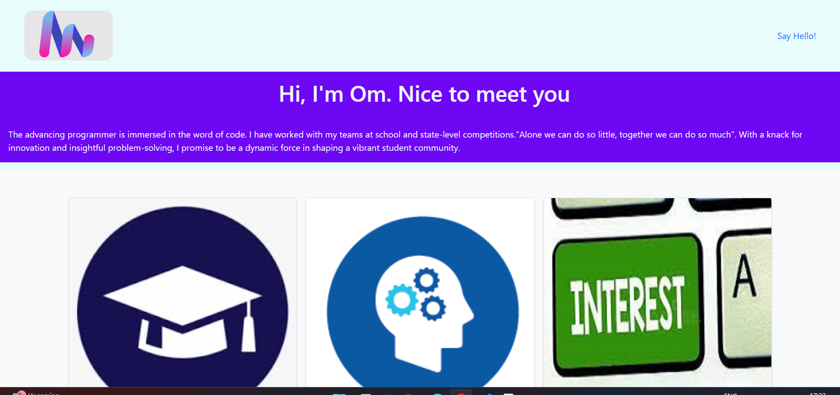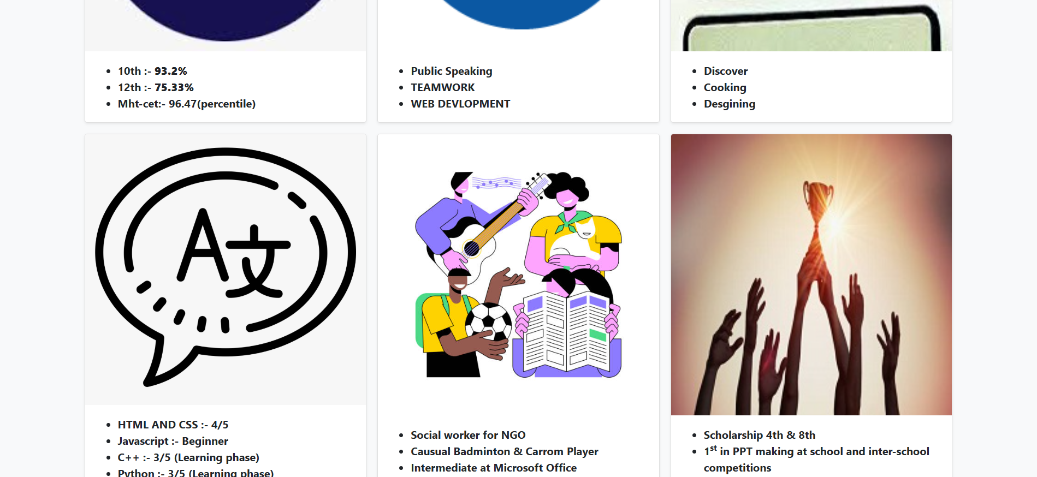
Post Lab Objective with Answer
- What is the Box model in CSS?
Ans. The box model consists of margins, borders, padding, and the content area of an element, which determines its layout and spacing on the webpage.

- What are the advantages of using CSS?
Ans. CSS separates content from design, enables responsive layouts, improves website performance, and allows reuse of styles for consistent design across multiple pages.

- What are the limitations of CSS?
Ans. Limited dynamic functionality, browser compatibility issues, and difficulty in debugging complex layouts without additional tools.
- What are the different types of Selectors in CSS?
Ans. Types of CSS Selectors:
- Universal Selector (*): Selects all elements.
- Type Selector (h1, p): Selects elements by tag name.
- Class Selector (.className): Selects elements with a specific class.
- ID Selector (#id): Selects an element with a unique ID.
- Attribute Selector: Targets elements based on attributes (e.g., [type="text"]).
- Pseudo-classes: Targets states like :hover.
- Pseudo-elements: Targets parts like ::before.

Date: 17/01/25 Signature of faculty in-charge

